VIM. Чтобы редактировать нажимаем i, после завершения жмем esc и вводим :wq

**Базовая настройка**

**МАШИНА ISP**

**1.** echo ISP > /etc/hostname

reboot

**2.** mkdir /etc/net/ifaces/ens3

mkdir /etc/net/ifaces/ens4

mkdir /etc/net/ifaces/ens5

vim /etc/net/ifaces/ens3/options

TYPE=eth

BOOTOROTO=dhcp

ONBOOT=yes

DISABLED=no

vim /etc/net/ifaces/ens4/options

TYPE=eth

BOOTOROTO=static

ONBOOT=yes

DISABLED=no

vim /etc/net/ifaces/ens4/ipv4address

172.16.4.1/28

vim /etc/net/ifaces/ens5/options

TYPE=eth

BOOTOROTO=static

ONBOOT=yes

DISABLED=no

vim /etc/net/ifaces/ens5/ipv4address

172.16.5.1 /28

**3.** echo nameserver 77.88.8.8 > /etc/net/ifaces/ens3/resolv.conf

vim /etc/net/sysctl.conf --> net.ipv4.ip_forward = 1

systemctl restart network

**4.** apt-get update && apt-get install iptables –y

iptables –t nat –A POSTROUTING –o ens3 –s 172.16.0.0/16 –j MASQUERADE

iptables-save > /etc/sysconfig/iptables

systemctl enable --now iptables

**МАШИНА HQ-RTR**

**1.** echo HQ-RTR.au-team.irpo > /etc/hostname

reboot

**2.** mkdir /etc/net/ifaces/ens3

mkdir /etc/net/ifaces/ens4

mkdir /etc/net/ifaces/ens4.100

mkdir /etc/net/ifaces/ens4.200

mkdir /etc/net/ifaces/ens4.999

mcedit /etc/net/ifaces/ens3/options

TYPE=eth

BOOTPROTO=static

ONBOOT=yes

DISABLED=no

mcedit /etc/net/ifaces/ens3/ipv4address

172.16.4.2/28

mcedit /etc/net/ifaces/ens3/ipv4route

default via 172.16.4.1

mcedit /etc/net/ifaces/ens4/options

TYPE=eth

BOOTPROTO=static

ONBOOT=yes

DISABLED=no

mcedit /etc/net/ifaces/ens4.100/options

TYPE=vlan

VID=100

HOST=ens4

BOOTPROTO=static

ONBOOT=yes

mcedit /etc/net/ifaces/ens4.100/ipv4address

192.168.100.1/26

mcedit /etc/net/ifaces/ens4.200/options

TYPE=vlan

VID=200

HOST=ens4

BOOTPROTO=static

ONBOOT=yes

mcedit /etc/net/ifaces/ens4.200/ipv4address

192.168.100.97/28

mcedit /etc/net/ifaces/ens4.999/options

TYPE=vlan

VID=999

HOST=ens4

BOOTPROTO=static

ONBOOT=yes

mcedit /etc/net/ifaces/ens4.999/ipv4address

192.168.100.113/29

**3.** echo nameserver 77.88.8.8 > /etc/resolv.conf

mcedit /etc/net/sysctl.conf --> net.ipv4.ip_forward = 1

systemctl restart network

**4.** iptables –t nat –A POSTROUTING –o ens3 –j MASQUERADE

iptables-save > /etc/sysconfig/iptables

systemctl enable --now iptables

apt-get update && apt-get install nano

**МАШИНА BR-RTR**

**1.** echo BR-RTR.au-team.irpo > /etc/hostname

reboot

**2.** mkdir /etc/net/ifaces/ens3

mkdir /etc/net/ifaces/ens4

mcedit /etc/net/ifaces/ens3/options

TYPE=eth

BOOTOROTO=static

ONBOOT=yes

DISABLED=no

mcedit /etc/net/ifaces/ens3/ipv4address

172.16.5.2/28

mcedit /etc/net/ifaces/ens3/ipv4route

default via 172.16.5.1

mcedit /etc/net/ifaces/ens4/options

TYPE=eth

BOOTOROTO=static

ONBOOT=yes

DISABLED=no

mcedit /etc/net/ifaces/ens4/ipv4address

192.168.100.65/27

**3.** echo nameserver 77.88.8.8 > /etc/resolv.conf

mcedit /etc/net/sysctl.conf --> net.ipv4.ip_forward = 1

systemctl restart network

**4.** iptables –t nat –A POSTROUTING –o ens3 –j MASQUERADE

iptables-save > /etc/sysconfig/iptables

systemctl enable --now iptables

apt-get update && apt-get install nano

**МАШИНА HQ-SRV**

**1.** echo HQ-SRV.au-team.irpo > /etc/hostname

reboot

**2.** mkdir /etc/net/ifaces/ens3

mkdir /etc/net/ifaces/ens3.100

mcedit /etc/net/ifaces/ens3/options

TYPE=eth

BOOTOROTO=static

ONBOOT=yes

DISABLED=no

mcedit /etc/net/ifaces/ens3.100/options

TYPE=vlan

VID=100

HOST=ens3

BOOTPROTO=static

ONBOOT=yes

mcedit /etc/net/ifaces/ens3.100/ipv4address

192.168.100.2/26

mcedit /etc/net/ifaces/ens3.100/ipv4route

default via 192.168.100.1

**3.** echo nameserver 77.88.8.8 > /etc/resolv.conf

mcedit /etc/net/sysctl.conf --> net.ipv4.ip_forward = 1

systemctl restart network

apt-get update && apt-get install nano

**МАШИНА BR-SRV**

**1.** echo BR-SRV.au-team.irpo > /etc/hostname

reboot

**2.** mkdir /etc/net/ifaces/ens3

mcedit /etc/net/ifaces/ens3/options

TYPE=eth

BOOTOROTO=static

ONBOOT=yes

DISABLED=no

mcedit /etc/net/ifaces/ens3/ipv4address

192.168.100.66/27

mcedit /etc/net/ifaces/ens3/ipv4route

default via 192.168.100.65

**3.** echo nameserver 77.88.8.8 > /etc/resolv.conf

mcedit /etc/net/sysctl.conf --> net.ipv4.ip_forward = 1

systemctl restart network

apt-get update && apt-get install nano

**GRE+FRR**

**После перезагрузки машины frr слетает, поэтому если что пишем *systemctl restart frr***

**МАШИНА HQ-RTR**

**1.** mkdir /etc/net/ifaces/gre1

nano /etc/net/ifaces/gre1/options

TUNLOCAL=172.16.4.2

TUNREMOTE=172.16.5.2

TUNTYPE=gre

TYPE=iptun

TUNTTL=64

TUNMTU=1476

TUNOPTIONS=’ttl 64’

nano /etc/net/ifaces/gre1/ipv4address

10.0.0.1 peer 10.0.0.2

systemctl restart network

**МАШИНА BR-RTR**

**1.** mkdir /etc/net/ifaces/gre1

nano /etc/net/ifaces/gre1/options

TUNLOCAL=172.16.5.2

TUNREMOTE=172.16.4.2

TUNTYPE=gre

TYPE=iptun

TUNTTL=64

TUNMTU=1476

TUNOPTIONS=’ttl 64’

nano /etc/net/ifaces/gre1/ipv4address

10.0.0.2 peer 10.0.0.1

ssytemctl restart network

**МАШИНА HQ-RTR**

**1.** apt-get install frr –y

nano /etc/frr/daemons --> ospfd=yes

systemctl enable --now frr

**2.**

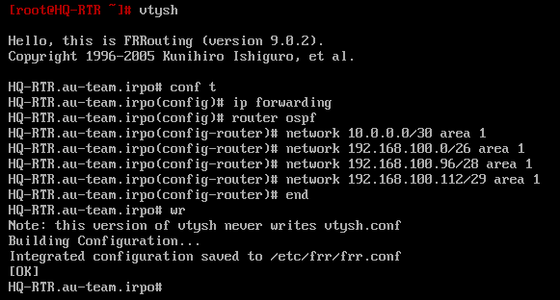

**МАШИНА BR-RTR**

**1.** apt-get install frr –y

nano /etc/frr/daemons --> ospfd=yes

systemctl enable --now frr

**2.**

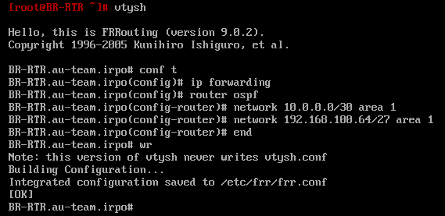

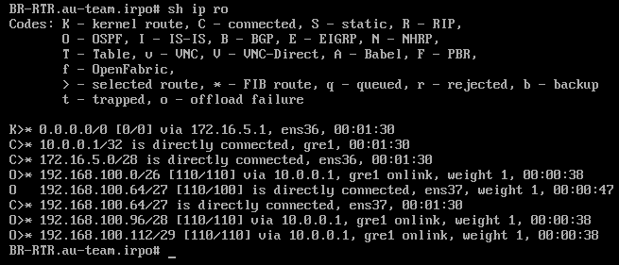

**Локальные учетные записи + SSH**

**МАШИНА HQ-SRV и BR-SRV**

**1.** adduser sshuser –u 1010

passwd sshuser --> P@ssw0rd

nano /etc/sudoers -->

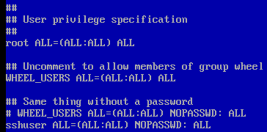

gpasswd –a sshuser wheel

control sudowheel enabled

**2.** nano /etc/openssh/sshd_config

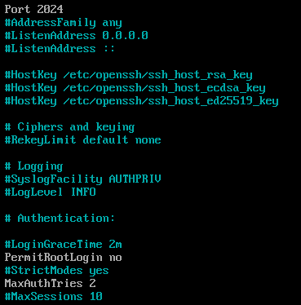





nano /etc/openssh/banner --> Authorized access only

systemctl restart sshd

**3.** Проверяем

C hq-rtr на br-rtr: ssh sshuser@192.168.100.66 -p 2024

C br-rtr на hq-rtr: ssh sshuser@192.168.100.2 -p 2024

**МАШИНА HQ-RTR и BR-RTR**

**1.** adduser net_admin

passwd net_admin --> P@ssw0rd

nano /etc/sudoers -->



gpasswd –a net_admin wheel

control sudowheel enabled

**DHCP + DNS**

**МАШИНА HQ-RTR**

**1.** apt-get install dnsmasq –y

rm -rf /etc/dnsmasq.conf

nano /etc/dnsmasq.conf

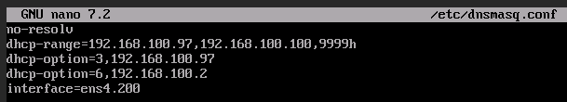

systemctl enable --now dnsmasq

**МАШИНА HQ-SRV**

**1.** apt-get install dnsmasq –y

rm -rf /etc/dnsmasq.conf

nano /etc/dnsmasq.conf

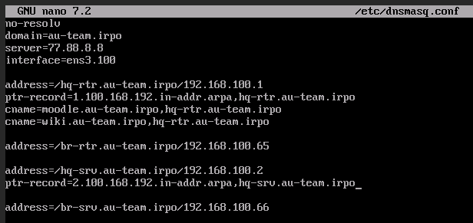

nano /etc/hosts

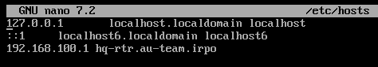

systemctl enable --now dnsmasq

**МАШИНА HQ-CLI**

**1.** echo HQ-CLI.au-team.irpo > /etc/hostname

reboot

**2.** mkdir /etc/net/ifaces/ens3

mkdir /etc/net/ifaces/ens3.200

mcedit /etc/net/ifaces/ens3/options

TYPE=eth

BOOTOROTO=static

ONBOOT=yes

DISABLED=no

mcedit /etc/net/ifaces/ens3.200/options

TYPE=vlan

VID=200

HOST=ens3

BOOTPROTO=dhcp

ONBOOT=yes

**3.** echo nameserver 77.88.8.8 > /etc/resolv.conf

mcedit /etc/net/sysctl.conf --> net.ipv4.ip_forward = 1

systemctl restart network

**МАШИНА HQ-SRV**

**1.** Добавляем две строчки

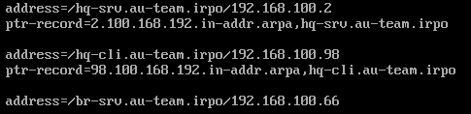

systemctl restart dnsmasq

**МАШИНА HQ-CLI**

**1.** systemctl restart network

**2.** Проверяем

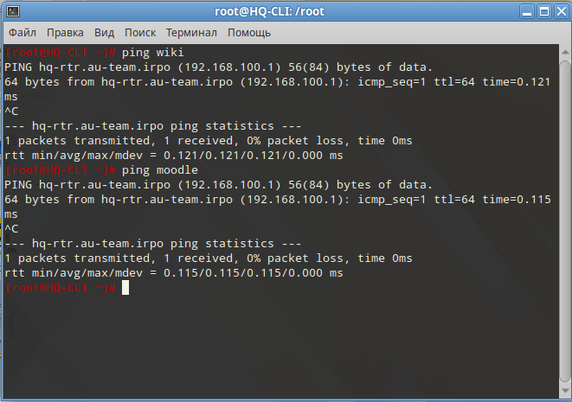

**Часовой пояс**

**МАШИНА ISP**

**1.** apt-get install tzdata systemd

systemctl restart systemd-timedated

timedatectl set-timezone Europe/Moscow

**ВСЕ ОСТАЛЬНЫЕ МАШИНЫ**

**1.** timedatectl set-timezone Europe/Moscow